Project title | Training Programs for Green Jobs in the Energy Sector
Sector | Employment, vocational training, renewable energy, just transition
Location | Jiu Valley, Hunedoara County, Romania
Project purpose | To reskill and upskill workers from coal-dependent industries for employment in the growing renewable energy sector. The project will provide vocational training in green energy technologies such as solar panel installation, wind turbine maintenance, and energy efficiency auditing. By preparing the workforce for the energy transition, the project will reduce unemployment and support the local economy in its transition away from coal.
Beneficiaries of the project | • Displaced coal miners and workers from traditional energy sectors in Jiu Valley.  • Local renewable energy companies and green technology businesses seeking skilled labour.  • The broader community will benefit from increased employment and a transition to a cleaner energy economy.
Project relevance and need | Jiu Valley is facing significant socio-economic challenges due to the decline of coal mining, with many workers at risk of unemployment. This project addresses the need to reskill these workers for the renewable energy sector, a key component of Romania’s energy transition strategy. By offering targeted vocational training programs, the project will equip individuals with the skills necessary to access sustainable and well-paid employment opportunities in green energy industries.
Implementing actor | National Agency for Employment
Activities | 1. Needs Assessment and Curriculum Development:  - Conduct a regional labour market analysis to identify the demand for specific green energy skills.  - Collaborate with local renewable energy companies, vocational schools, and training centres to develop tailored curricula for green job training.  2. Recruitment and Outreach:  - Engage displaced workers and jobseekers from coal-dependent industries to participate in the training programs.  - Partner with local employment agencies, unions, and community organizations to promote the programs.  3. Training and Certification:  - Offer practical, hands-on training in renewable energy technologies such as solar panel installation, wind turbine maintenance, energy auditing, and energy-efficient building retrofitting.  - Provide certification upon program completion, enabling trainees to seek employment in the green energy sector.  4. Job Placement and Career Support:  - Work with local renewable energy companies and employment agencies to assist trainees in finding jobs after completing the program.  - Offer ongoing career support, including resume writing, interview preparation, and job search assistance.  5. Partnership Building and Networking:  - Foster partnerships between local businesses, NGOs, vocational schools, and renewable energy companies to ensure continued collaboration and support for green job initiatives.
Expected result(s) | • Reskilled workforce: 300 workers trained and certified for employment in renewable energy and energy efficiency sectors.  • Job creation: Increased employment opportunities in the local renewable energy industry.  • Sustainability: A local workforce prepared for long-term employment in green technologies, reducing reliance on coal-based jobs.
Expected contribution(s) and impact(s) | • The program will significantly reduce unemployment among displaced coal workers by providing them with the skills needed for jobs in the renewable energy sector.  • Local businesses in the green energy industry will benefit from a skilled workforce, boosting the local economy.  • The project will support Romania’s just transition goals by contributing to the development of a sustainable, low-carbon economy.
Institutional framework | • The project will be led by local and regional authorities in partnership with vocational training centres, renewable energy companies, and local NGOs.  • Support will be provided by employment agencies, educational institutions, and green energy businesses.
Budget | Total budget: 350,000 EUR  - Labour market analysis and curriculum development: 50,000 EUR  • Training program delivery and certification: 200,000 EUR  • Job placement and career support: 50,000 EUR  • Outreach, networking, and partnership building: 50,000 EUR
Sources of funding or financing | • Just Transition Fund  • EU Social Fund  • National Employment and Training Programs  • Contributions from local businesses and energy companies
Implementation schedule | - Needs assessment and curriculum development: January 2025 - April 2025  - Training program launch and recruitment: May 2025 - August 2025  - Program delivery and certification: September 2025 - February 2026  • Job placement and support: March 2026 - July 2026  • Project completion: July 2026
Sustainability | • The skills acquired through the training programs will provide long-term employment opportunities in the renewable energy sector.  • Partnerships with local businesses will ensure that graduates are employed in the region, contributing to the local economy.  • The program will be financially sustainable through ongoing support from local authorities, businesses, and potential future funding sources.
Replication | This training program model can be replicated in other coal-dependent regions across Romania, where similar socio-economic challenges exist. The approach can also be expanded to cover additional green energy sectors such as energy storage and electric vehicle maintenance, further supporting Romania’s just transition.


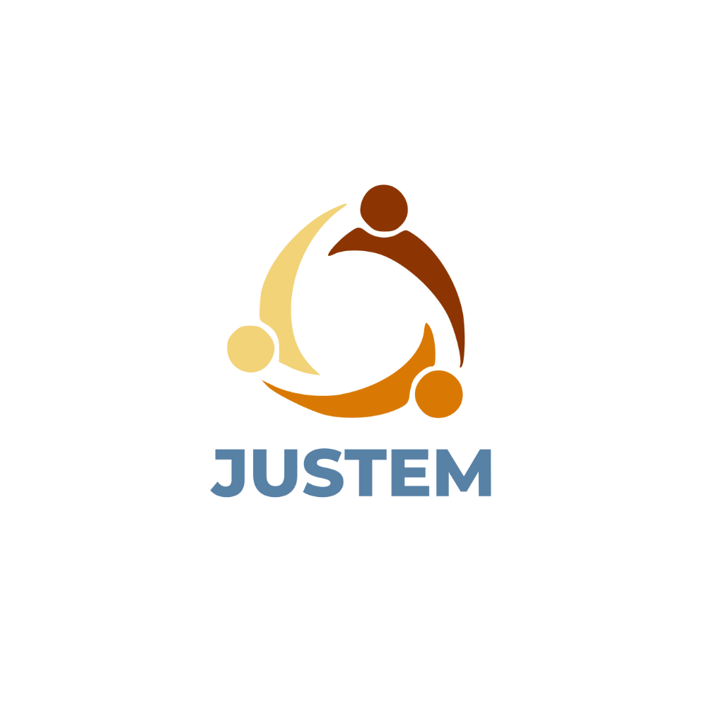
September, 2024
Date of release
Loriana Farkas, AISVJ
Sabina Irimie, AISVJ
Adrian-Lucian Pal, AISVJ
Authors
ABOUT
Co-funded by the European Union. Views and opinions expressed are however those of the author(s) only and do not necessarily reflect those of the European Union or CINEA. Neither the European Union nor the granting authority can be held responsible for them.

